[Licensing your Karamba3D](javascript:void(0))

Before licensing: The faculty’s Karamba3D license is only available within the campus network. Your device must connect to the campus network (the campus ethernet, the ‘HKU’ wi-fi, or the [HKUVPN](https://its.hku.hk/services/network-connectivity/hkuvpn/) if you are outside campus) during licensing and use of the software.

HKUVPN: https://its.hku.hk/services/network-connectivity/hkuvpn/  
To license:

1. Download and install Karamba3D from [here](https://karamba3d.com/get-started/) (https://karamba3d.com/get-started/); download and uncompress the faculty's license file *licensePRO.lic* from [here](https://foaintranet.arch.hku.hk/wp-content/uploads/2025/02/licensePRO.lic_.zip). (https://foaintranet.arch.hku.hk/wp-content/uploads/2025/02/licensePRO.lic_.zip)
2. Run Rhino as administrator. You will need to have administrator rights on your computer.
3. Type **"Grasshopper"** in the Command Line to load Grasshopper.
4. Drag and drop the "License"-component (the red “K” icon) on the grasshopper canvas. This can be found in the Karamba3D tab.  
    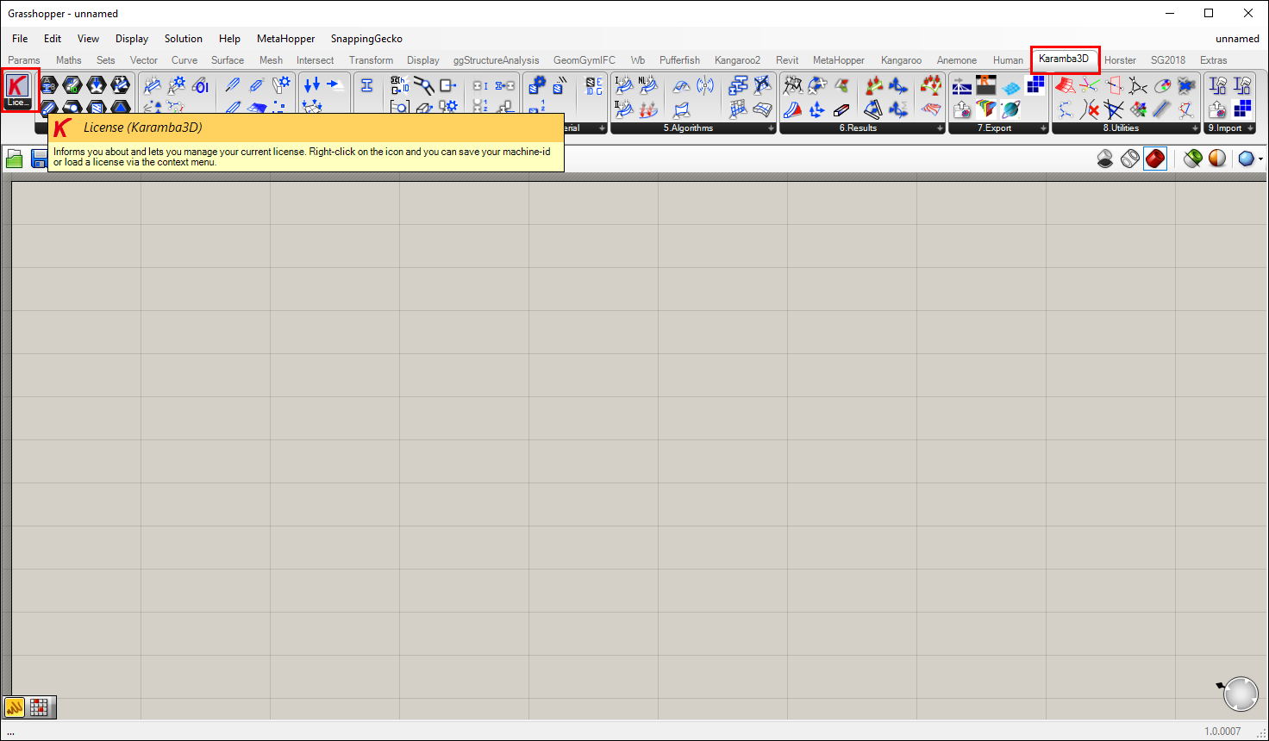
5. Right click on the "License" label. Select "Load license file" from the menu.  
   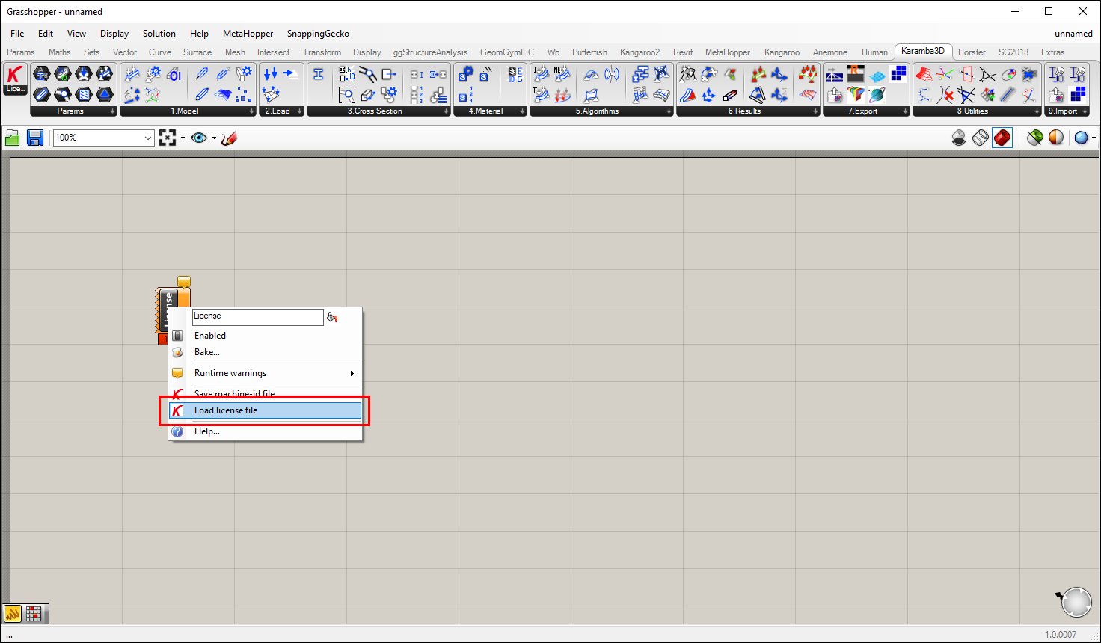
6. Locate the *licensePRO.lic* that you downloaded. Click "Open" to load the license.
7. Restart Rhino, type **"Karamba3DGetLicense"** in the Command line.
8. A window should pop up. Select "Use the Zoo".

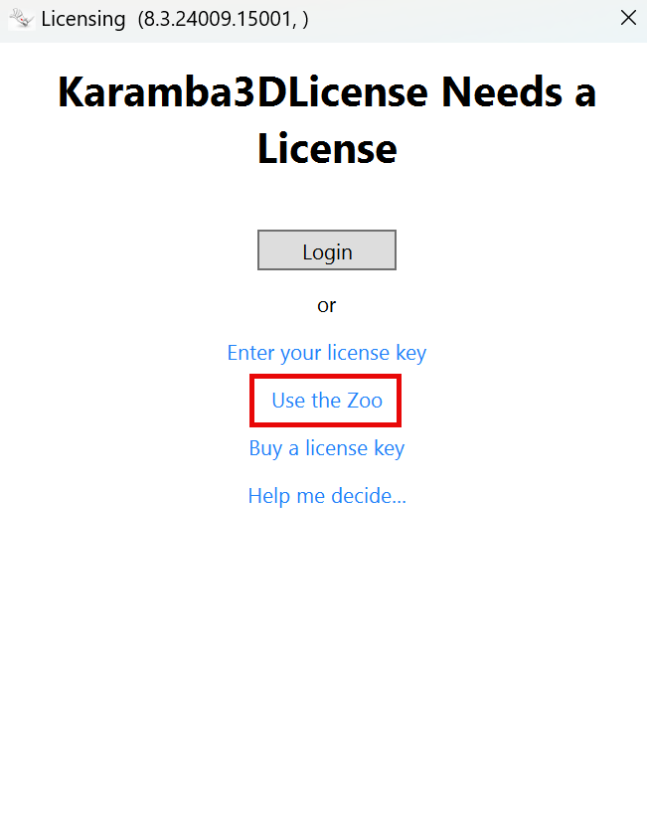

1. Select Use Zoo Server with following host name or IP. Then type “apps.ad.arch.hku.hk” into the text field.

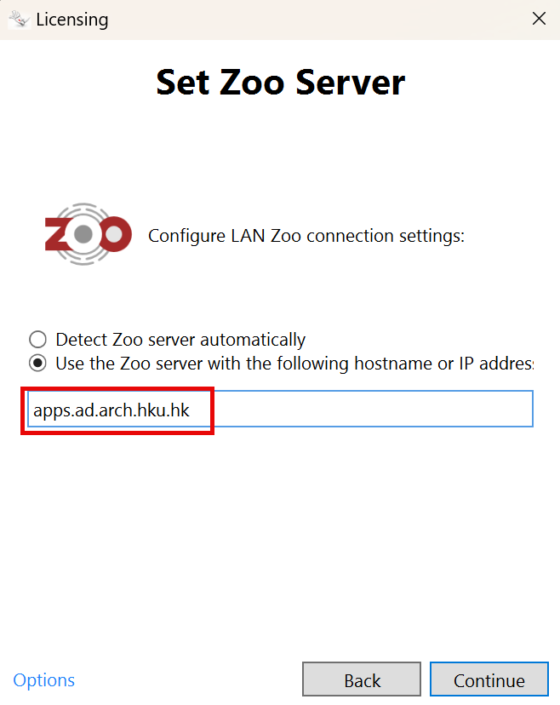

1. The license will load from the zoo and the license information will be displayed in the Command Line.